MINI PROJECT DOCUMENTATION BYFATHIMA RESMIN F (69)

CLOTHINHG SALE DATASET
OBJECTIVE:
The goal of this project is to analyse sales performance, customer purchasing behaviour, and profitability trends by performing data cleaning, transformation, and exploratory data analysis using Excel and Power BI.
Dataset Details
The dataset contains transaction-level sales information. Based on the columns visible in your spreadsheet, the schema details are as follows:
• Order ID: Unique identifier for each sales transaction.
• Customer Name: Name of the customer who made the purchase.
• Product Category & Product Name: Details regarding the category (e.g., Accessories, Dresses, Shoes, Jackets) and specific item purchased.
• Units Sold & Unit Price: Quantity of items bought and the price per unit.
• Discount: Discount percentage applied to the transaction.
• Sale Amount: Total revenue generated from the sale after calculations.
• Order Date: The date when the order was placed (ranging across 2023).
• City & Segment: Geographic location (e.g., Mumbai, Ahmedabad, Pune, Delhi, Bangalore, Hyderabad) and customer segment (B2C, B2B).
• Profit & Performance Status: Financial profitability and performance rating (e.g., Normal, High Sales).
• City Code: Short code representation for cities.

PHASE 1
Data Processing & Step-by-Step Implementation
Step 1: Data Cleaning & Preprocessing (Excel / Power Query)
• Handling Missing Values: Checked for missing or null values in critical columns (such as Customer Name, Units Sold, and Unit Price) and cleaned them.
• Data Type Formatting: Formatted dates (Order Date), financial numbers (Sale Amount, Unit Price, Profit), and quantities (Units Sold) into appropriate data types.
• Removing Duplicates: Checked and removed any duplicate rows based on Order ID to maintain data accuracy.
Step 2: Calculated Columns & Custom Formulas (Excel)
• Revenue Calculation: Created calculated formulas/columns to determine total values based on units sold, unit prices, and applied discounts.
• Performance Status Flagging: Used logical functions (such as nested IF statements) to categorize transactions into performance tiers like High Sales or Normal.
Step 3: Pivot Table & Pivot Chart Generation (Excel)
• Category & Regional Summaries: Built Pivot Tables to summarize total sales and profits across different product categories and cities (e.g., Mumbai, Ahmedabad, Delhi, Bangalore).
• Customer Segmentation Pivot: Created summary matrices to evaluate purchasing patterns between B2B and B2C segments.
Step 4: Conditional Formatting (Excel)
• Applied conditional formatting rules to highlight high-performing sales rows, high profit margins, or specific product categories to make reports visually intuitive.
Step 5: Advanced Formulas & Data Analysis Features (Excel)
• Calculated Columns & Nested IF Functions: Implemented custom formulas and nested IF logic to dynamically calculate final revenues, apply discounts, and categorize transaction performance statuses (e.g., High Sales vs. Normal).
• Sorting & Filtering Tools: Utilized Excel's advanced data filtering and sorting options to isolate specific date ranges, top-performing cities, and high-value customer orders for deeper exploratory analysis.

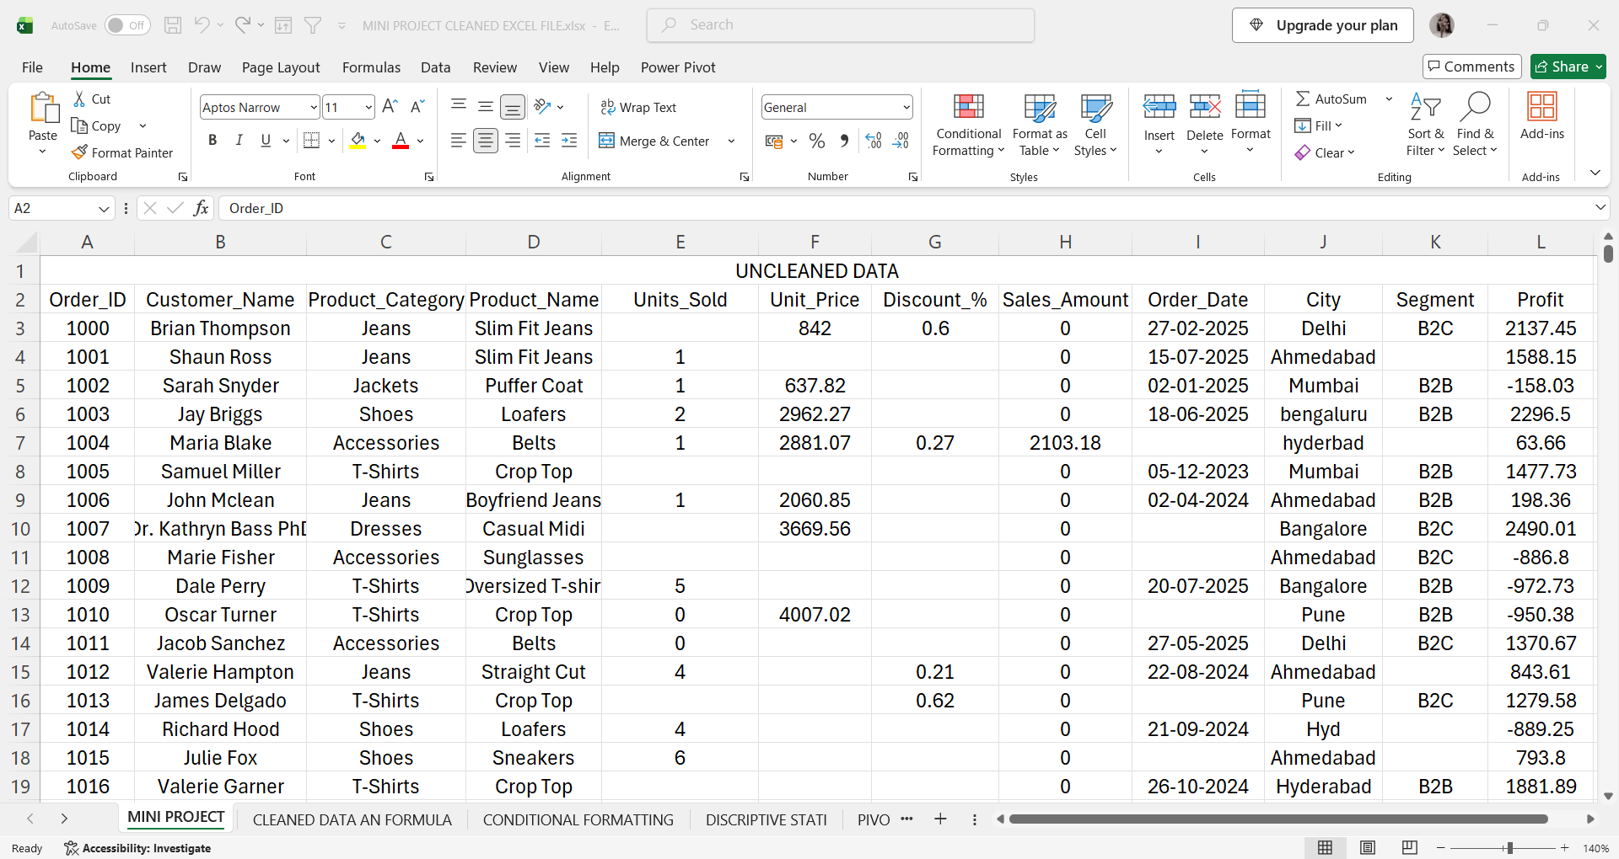
UNCLEANED DATASET ANALYSIS & IDENTIFIED ISSUES

Dataset Condition: This sheet contains raw data that is unorganized, messy, and scattered. Many columns contain missing information or incorrectly recorded values.
* Order – Checked for missing and duplicate order IDs.
* Customer Name – Checked for missing names and spelling inconsistencies.
* Product Category – Checked and standardized category names.
* ProductName – Checked for missing or incorrect product names.
* Units Sold – Checked missing values and incorrect/negative quantities.
* Unit Price – Checked missing and invalid price values.
* Discount_% – Checked missing values and standardized discount values.
* Sales Amount – Checked missing/incorrect values and recalculated where required.
* Order Date – Checked missing dates and standardized the date format.
* City – Checked missing values and standardized city names (e.g., Bangalore/Bengaluru).
* Segment – Checked missing values and standardized B2B/B2C entries.
* Profit – Checked missing and incorrect profit values and verified the calculate

• The raw data was messy, disorganized, and scattered. Several cells had missing numbers, blank spaces, or incorrect values in important columns like Unit Price, Discount, and Sale Amount. Because of these errors, we could not use this data directly to make charts or reports.

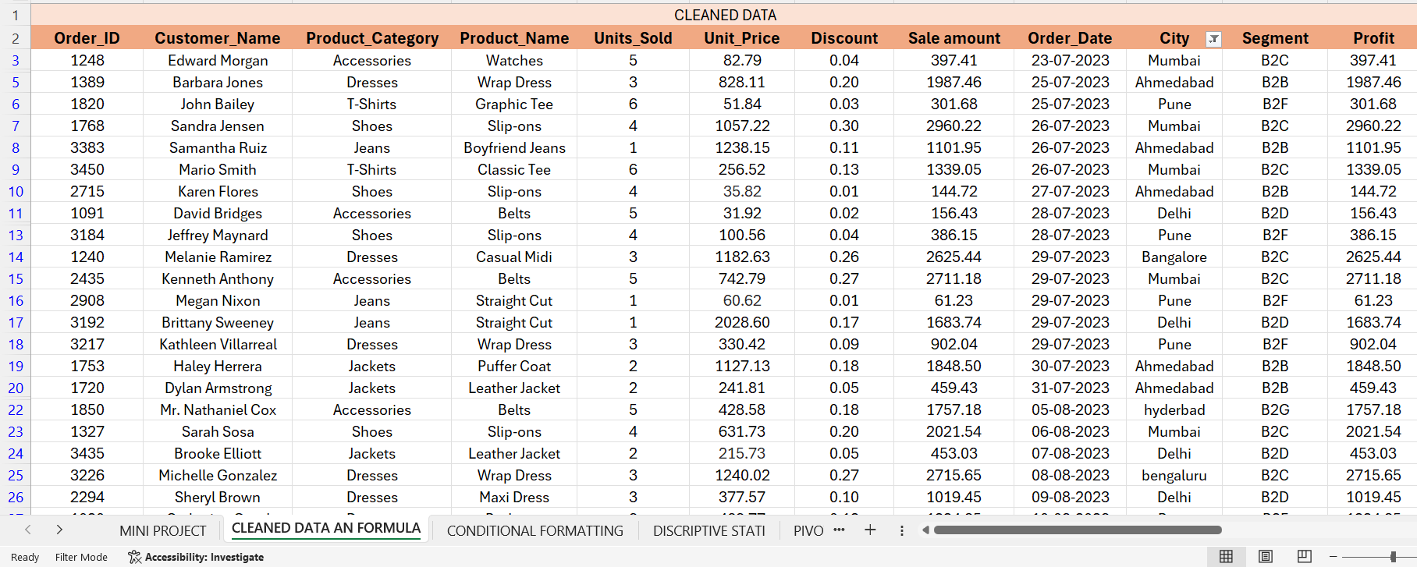
1. INITIAL DATA CLEANING IN EXCEL

This is the first step of the project, where the raw/un-cleaned dataset was imported and examined in Microsoft Excel.
* Order: Checked duplicates/missing values – Filter
* Customer Name: Checked missing data – Filter
* Product Category & ProductName: Standardized values – Filter
* Units Sold & Unit Price: Checked incorrect values – Filter & Formula
* Discount & Sale Amount: Corrected/calculated – Formula & Number Format
* Order Date: Standardized date format – Date Format
* City & Segment: Standardized values – Filter
* Profit: Verified calculations – Formula (Tools used: Filter, Sort, Formulas, Number/Date, Remove Duplicates.)
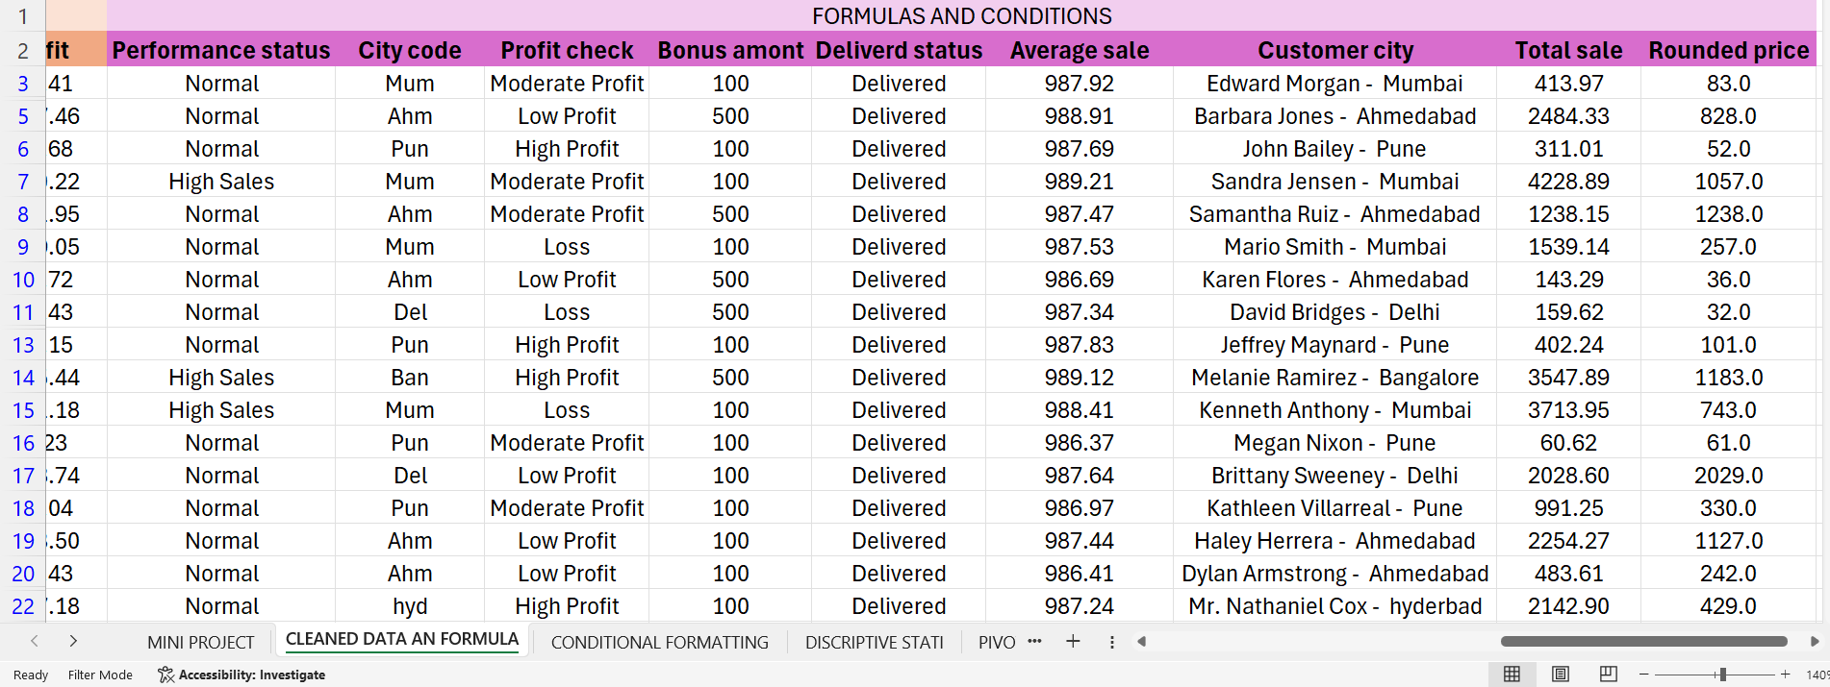
2. FORMULAS AND CONDITIONS

* Performance Status – Used IF condition to classify sales performance.
* City Code – Used IF conditions to create short city codes.
* Profit Check – Used IF condition to classify profit as High, Moderate, or Low.
* Bonus Amount – Used IF condition to assign bonus amounts based on performance/profit.
* Delivery Status – Used IF condition to determine delivery status.
* Average Sale – Used AVERAGE formula to calculate average sales.
* Customer City – Combined customer name and city using an Excel text formula.
* Total Sale – Used SUM/SUMIF to calculate total sales.
* Rounded Price – Used ROUND formula to round price values.
Main formulas used: IF, SUM/SUMIF, AVERAGE, ROUND and text/conditional formulas.
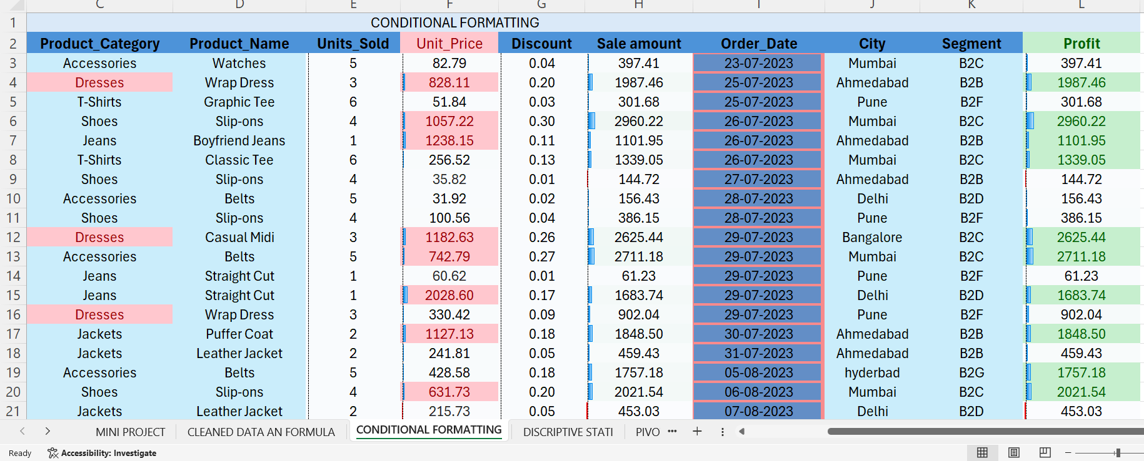
3.CONDITIONAL FORMATTING

Conditional Formatting was used in Excel to highlight important values in the dataset based on specific conditions.
* Product Category: Used Text-based rules to highlight selected categories.
* Unit Price: Used Greater Than / Less Than rules to identify high and low prices.
* Discount: Used value-based conditions to highlight selected discount values.
* Sale Amount: Used Greater Than / Less Than rules to identify higher and lower sales.
* Order Date: Used Date-based rules to highlight selected dates.
* Profit: Used Greater Than / Less Than rules to identify high and low profit values.(Tools Used Conditional Formatting → Highlight Cells Rules → Greater Than, Less Than, Text/Date Rules.)
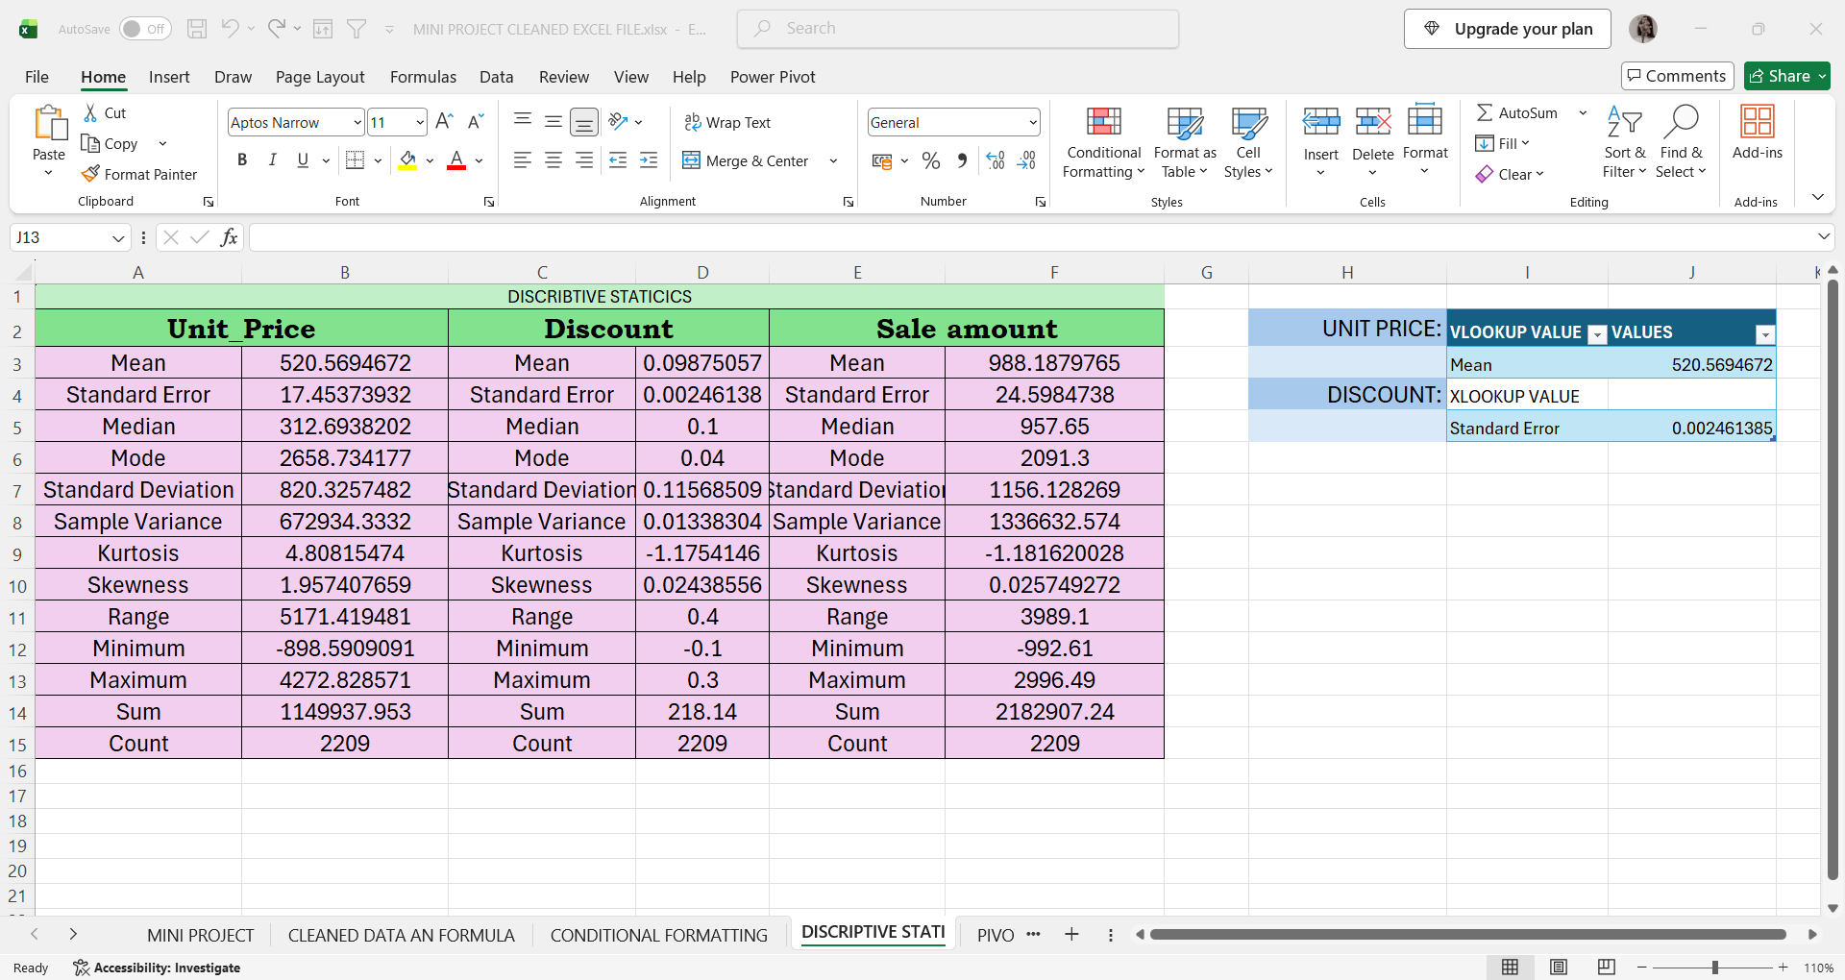
4.DESCRIPTIVE STATISTICS & LOOKUPS

Descriptive Statistics was used to summarize and analyze the dataset using Excel Data Analysis tools.
* Unit Price: Calculated Mean, Median, Mode, Standard Deviation, Variance, Range, Minimum, Maximum, Sum and Count.
* Discount: Calculated the same statistical measures to understand discount values.
* Sale Amount: Calculated statistical measures to analyze sales performance.
* VLOOKUP: Used to retrieve the required statistical value from the table.
* XLOOKUP: Used to search and return specific values such as Mean and Standard Error.
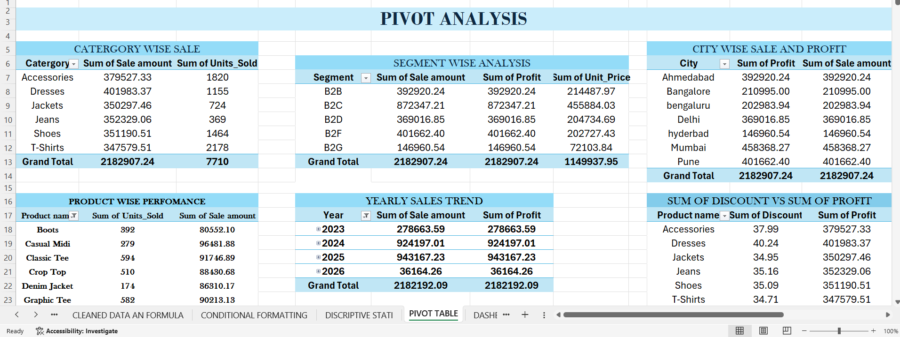
5.PIVOT TABLE ANALYSIS

Pivot Tables were created from the cleaned Excel dataset to summarize and analyse the data.
* Category-wise Sales: Analysed sales amount and units sold by product category.
* Segment-wise Analysis: Compared sales, profit, and unit price across customer segments.
* City-wise Sales & Profit: Analysed sales and profit based on city.
* Product-wise Performance: Compared units sold and sales amount by product.
* Yearly Sales Trend: Analysed sales and profit year-wise.
* Discount vs Profit: Compared discount and profit for each product category.
(Tools used: Excel PivotTable, Rows, Columns, Values, Filters, and Sum calculations.)
Purpose: Pivot Tables helped to summarize large amounts of data and identify important sales, profit, product, city, segment, and yearly trends for further analysis.
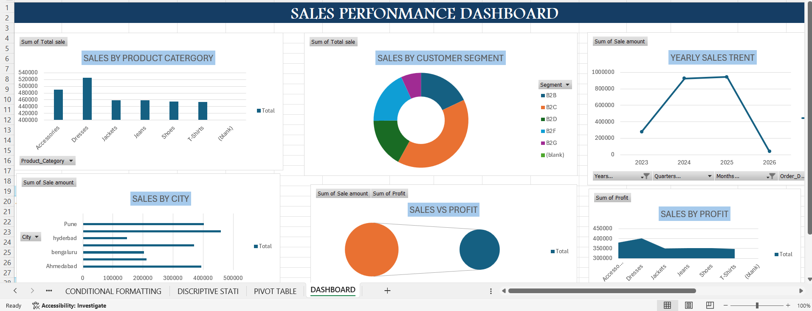
6.EXCEL DASHBOARD

After completing the data cleaning and analysis, an Excel Dashboard was created to present the results visually. * Sales by Product Category – Compared sales across product categories.
* Sales by Customer Segment – Showed sales distribution among segments.
* Yearly Sales Trend – Displayed sales performance year-wise.
* Sales by City – Compared sales across different cities.
* Sales vs Profit – Compared sales and profit.
* Sales by Profit – Presented profit performance visually.
Charts used: Column Chart, Doughnut Chart, Line Chart, Bar Chart, and Area Chart.
Overall Excel Process:
Raw Data → Data Cleaning → Formatting → IF/Formula Conditions → Conditional Formatting → Descriptive Statistics → Pivot Tables → Charts → Dashboard
The complete Excel data preparation and analysis process was completed first. The cleaned and structured Excel dataset will then be used in Power BI for further data transformation, visualization, and interactive dashboard creation.
PHASE
POWER BI DASBOARD
After cleaning in excel power bi used to visualize data. Power BI was used to create interactive dashboards for analysing sales performance, profit, customer information, geographical data, and business insights.
A suitable dark and professional theme with contrasting light visual areas was used to make the dashboard attractive, readable, and easy to understand. Different charts, cards, maps, tables, slicers, and interactive elements were added to present the information clearly
In this sale dashboard I use maroon and cream colour combination for that elegant look and use icon at left side of all dashboard

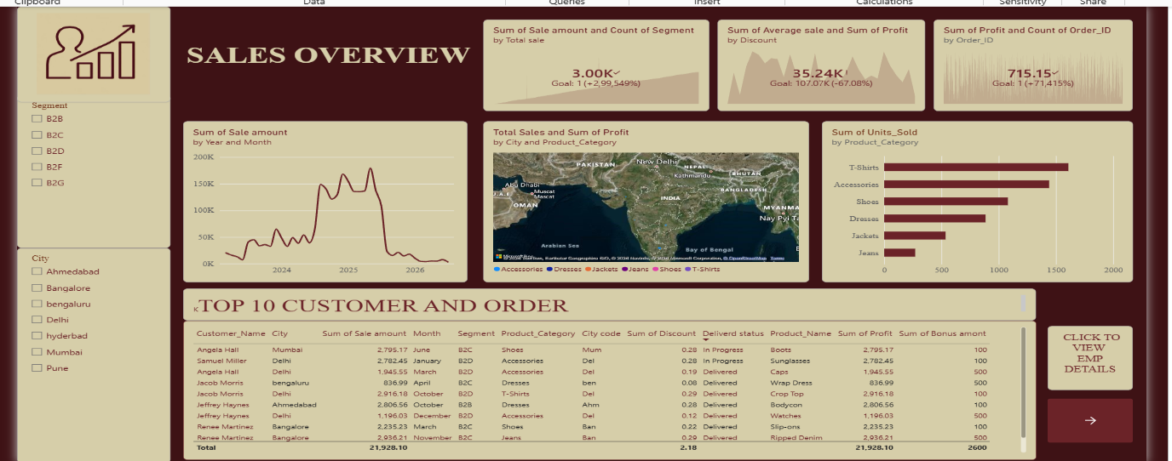
DASHBOARD 1 – SALES OVERVIEW

The first dashboard is Sales Overview, which provides an overall view of sales performance.
Visuals used:
* KPI Cards – Total Sales, Profit, Average Sales, Orders, etc.
* Line Chart – Shows the sales trend over time.
* Map Visual – Shows sales and profit by geographical location.
* Bar Chart – Shows units sold by product category.
* Table – Displays Top 10 customers and their order details.
* Slicers – Used to filter the dashboard by Segment and City.
* Navigation Button – Used to move to employee/details pages.
Purpose of the Sales Overview Dashboard: Monitor overall sales performance. Identify top-performing products and customers. Analyse sales trends over time.
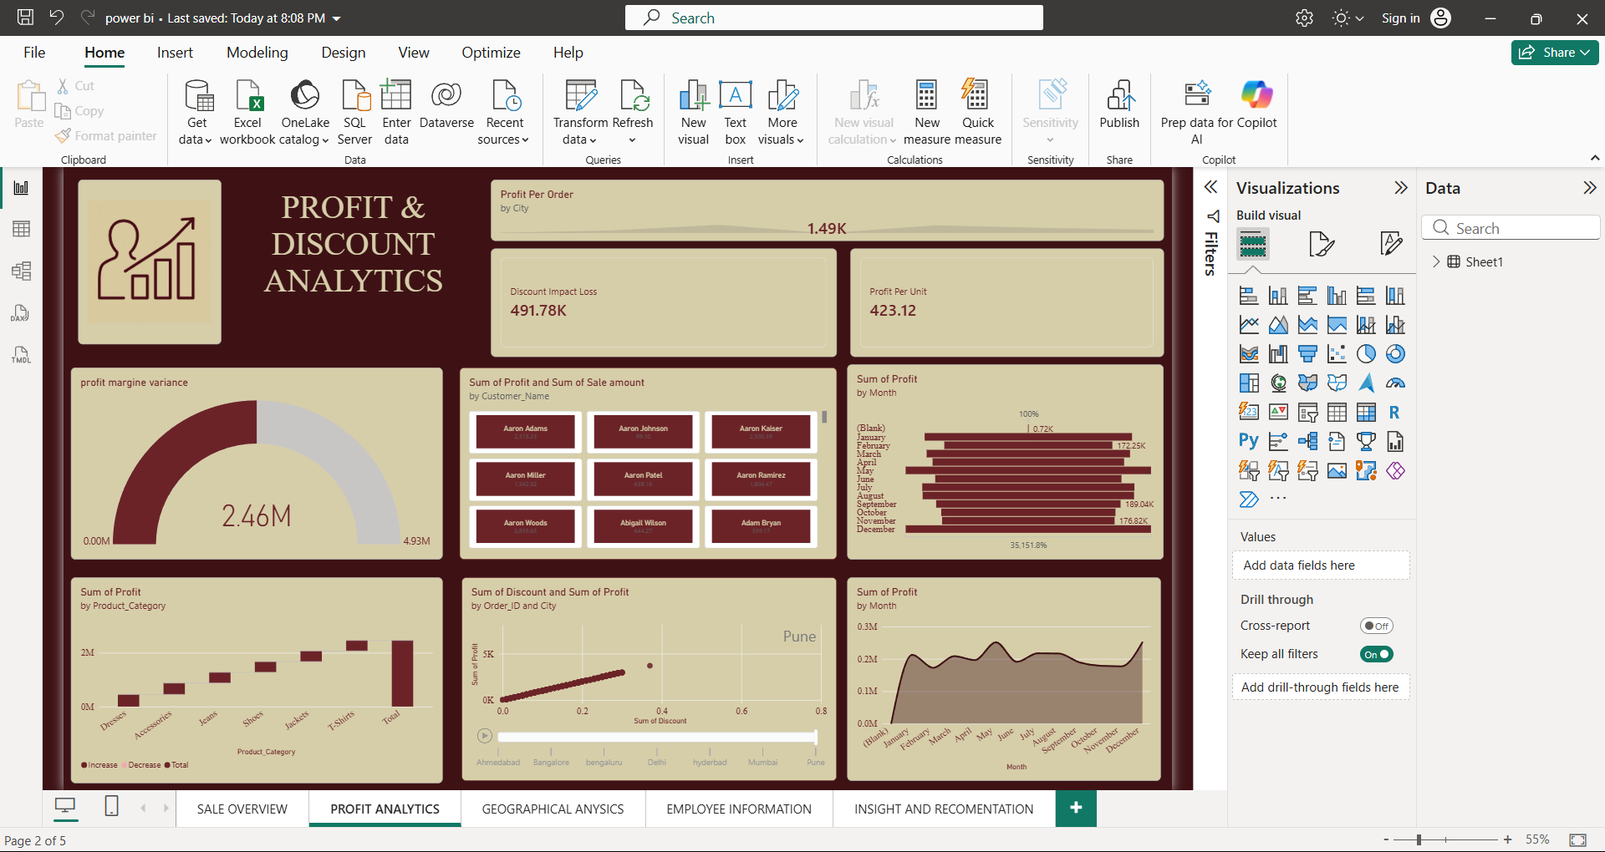
DASHBOARD 2 – PROFIT & DISCOUNT ANALYTICS

The second Power BI dashboard is Profit & Discount Analytics. It focuses on analysing profit performance, discount impact, profit per order, and profit trends.
Visuals used:
* KPI Cards – Display Profit per Order, Discount Impact/Loss, and Profit per Unit.
* Gauge Chart – Shows Profit Margin Variance.
*Bar Chart – Shows Profit by Month.
* Waterfall Chart – Shows Profit by Product Category.
* Scatter Chart – Analyses the relationship between Discount and Profit by Order/City.
* Area Chart – Shows monthly Profit trends.
Purpose of this dashboard:
* Provides a clear view of overall profit performance.
* Helps identify the impact of discounts on profit.
* Makes high- and low-profit products easier to identify.
* Shows monthly profit trends.
* Supports better pricing and discount decisions.
Overall: This dashboard helps management understand where profit is generated, how discounts affect profit, and how profit changes over time, supporting better business decisions.

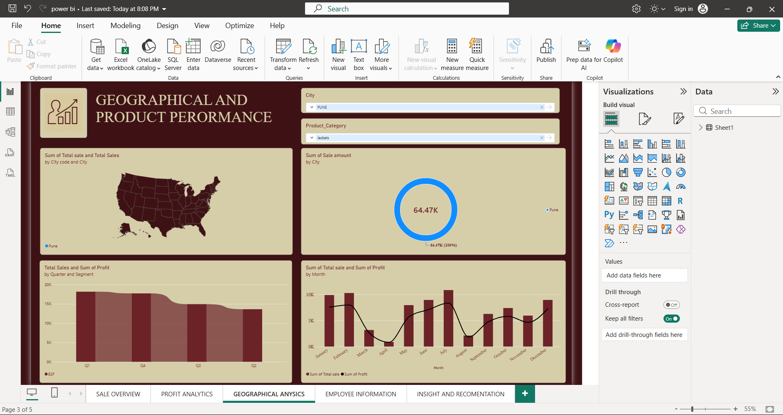
DASHBOARD 3 – GEOGRAPHICAL & PRODUCT PERFORMANCE

The third Power BI dashboard is Geographical and Product Performance. It is designed to analyse sales performance across different locations and product categories.
Features and Visuals Used
* Map Visual: Shows geographical sales distribution by location.
* Donut Chart: Displays sales amount for the selected city.
* Column/Area Chart: Compares total sales and profit by quarter and segment.
* Combo Chart: Compares total sales and profit month-wise.
* City Slicer: Allows users to select and analyse a specific city.
* Product Category Slicer: Allows filtering based on product category.
Purpose of this chart:
* Identifies sales performance across different geographical areas.
* Shows the sales contribution of selected cities.
* Compares sales and profit across quarters and months.
* Helps analyse the performance of different product categories.
* Interactive filters allow users to focus on specific cities and products.
The dashboard provides a clear view of geographical and product performance. It helps identify which cities and product categories contribute more to sales and profit. The analysis also shows quarterly and monthly changes in sales and profit, making it easier to identify high- and low-performing periods. By using interactive City and Product Category slicers, specific locations and products can be analysed in detail.
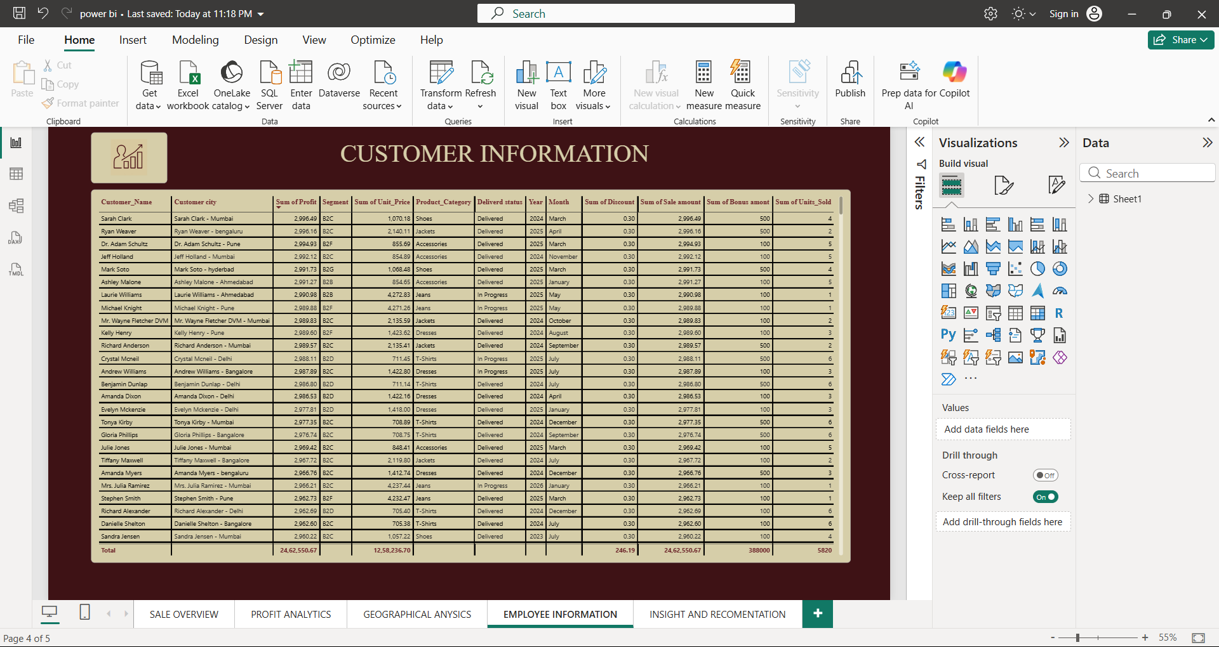
DASHBOARD 4 – EMPLOYEE AND CUSTOMER INFORMATION
The fourth dashboard is the Employee Information Dashboard, which provides detailed information about customers and their related sales performance. It contains important fields such as Customer Name, Customer City, Profit, Segment, Unit Price, Product Category, Delivery Status, Year, Month, Discount, Sales Amount, Bonus Amount, and Units Sold.
A navigation button is also used in the dashboard. From Dashboard 1 – Sales Overview, the user can click the “Click to View CUSTOMER Details” button to directly navigate to Dashboard 4. This makes it easier to move from the overall sales summary to the detailed customer-level information without manually searching through different pages.
Key Features
* Provides complete customer and employee-related details.
* Shows profit, sales amount, discount, bonus, and units sold.
* Displays information based on city, segment, product category, year, and month.
* Shows delivery status and other important details.
* Uses a button/page navigation feature to move from Dashboard 1 to Dashboard 4.
* Allows users to view detailed information after starting from the overall Sales Overview.
Purpose and Uses:
The main purpose is to provide detailed customer-level information from the overall sales dashboard. The navigation button improves the usability of the report by allowing users to move directly from the summary dashboard to the detailed information page.
Overall, Dashboard 4 acts as a detailed information page connected to the main Sales Overview dashboard through button navigation, making the Power BI report more interactive, organized, and user-friendly.
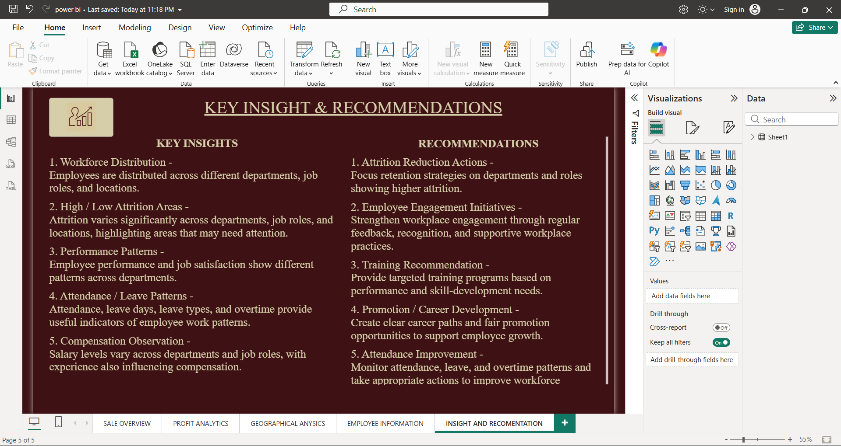
5 – KEY INSIGHTS & RECOMMENDATIONS

Dashboard 5 helps the company turn data analysis into practical decisions. It identifies important areas such as employee performance, attendance, attrition, training needs, and compensation.
Uses for the company:
* Helps management make better data-driven decisions.
* Identifies areas with high employee attrition.
* Helps improve employee performance and engagement.
* Supports training and career development.
* Helps improve attendance and workforce planning.
* Provides recommendations for future improvement.

Achievements:
The company can achieve better employee retention, improved productivity, stronger employee engagement, effective workforce management, and better decision-making by following the insights and recommendations from the dashboard.

Conclusion and Learning Outcomes
This mini-project provided practical experience in Microsoft Excel and Power BI and helped me understand the complete process of data analysis.
First, I learned how to clean and prepare raw data in Excel, including handling missing values, correcting data, formatting, and organizing the dataset. I also learned to use Excel formulas, IF conditions, statistical functions, Conditional Formatting, VLOOKUP, XLOOKUP, Pivot Tables, and Charts.
Through this project, I gained a better understanding of how Excel can be used to analyse data and create meaningful reports and dashboards.
I also learned the basics of Power BI data visualization. I understood how to import cleaned data, create different visualizations, use filters and slicers, design interactive dashboards, and present important insights and recommendations.
The mini-project helped me improve my data analysis, visualization, problem-solving, and decision-making skills. Overall, this project gave me practical knowledge of how raw data can be transformed into meaningful insights for business decision-making.

